**Team-7:Unstoppable**

**Team Leader: Mohit Kadam**

**Problem: When vehicle suddenly stop on the road then what can we do?**

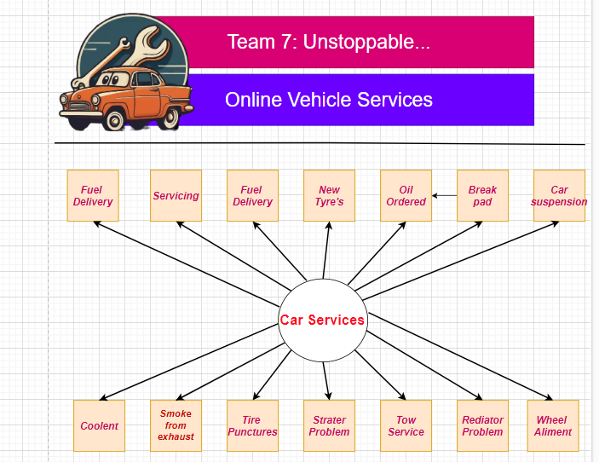

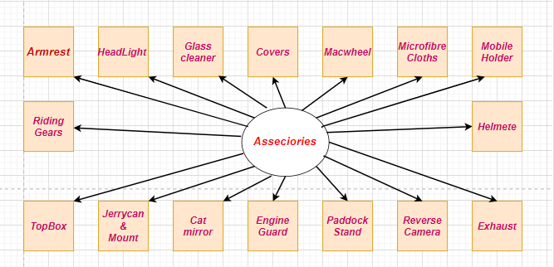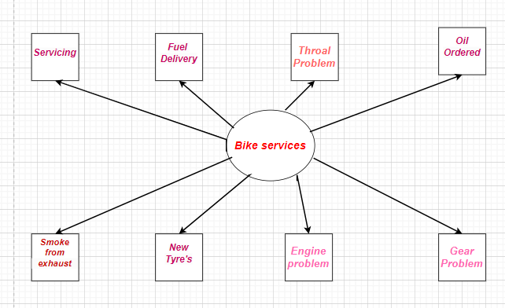

**Activity 3:**

**5W-1H Activity**

**Team : Unstoppable**

**Project Title: Online Vehicle Services**

|  |  |  |
| --- | --- | --- |
| **Aspect** | **Questions** | **Details** |
| **Who** | **Who are the stakeholders?** | **Anyone can use (Farmer,Businessman,Normal person etc.)** |
|  |
|  |
|  |
| **What** | **What is the problem?** | **Vehicle owners have to search far and wide for reliable and appropriate garage services to sort out their cars whenever there is a problem. Just some of the issues caused by this are delays, inefficiencies, and potentially unsafe vehicles on the road.** |
|  |
|  |
|  | **What is the solution?** | **Build an online garage service application so vehicle owners are connected to trusted, convenient garage services that provide proper scheduling and management of service, efficient and safe practices for the maintenance and repair the vehicles.** |
|  | **What are the key features?** | **1. Search and book garage services**  **2. prices and services**  **3. Read reviews and ratings**  **4. Schedule appointments**  **5. vehicle service history**  **6.Make online payments** |
|  |
|  |
|  |
|  |
| **Where** | **Where will the system be used?** | **1. Urban areas** |
| **2. Rural areas** |
| **3. Suburban areas** |
|  | **Where will the solution be developed and tested?** | **Primary development center** |
|  |
| **When** | **When is the device needed?** | **When in our car or bike some issue then** |
|  |
|  | **When should the project be completed?** | **2/3 months** |
|  |
| **Why** | **Why is this project important?** | **1.Convenience: The online garage service app will provide a very convenient and user-friendly platform for vehicle owners to manage all their servicing and repair works of vehicles.**  **2. Efficiency: The application will certainly give a clean chit to the scheduling and management procedures, reducing the waiting time and enhancing the total experience of the vehicle owner.**  **3. Transparency: It is going to offer transparent prices, services, and reviews to the vehicle owner for executing an informed decision.**  **4. Accessibility: More accessibility to the app for vehicle owners who are less mobile, live in remote areas, or have jam-packed schedules.** |
|  |
|  |
|  | **Why will the users adopt this solution?** | **1. Convenience: I am always there, and accordingly, I am available to the user at any time he/she needs help.**  **2. Time-saving: Everything needed for the answer, definitions, and information is available on the fly.**  **3. Customized experience: Very easily, my functionality would fit in the needs and preferences of this or that peculiar user.**  **4. High accessibility: I can also be of help to persons with special needs, to those for whom language is a barrier, or who simply cannot work with a conventional interface.**  **5. Fun and engaging: The interaction with me can be fun and interesting, which means the experience will be more pleasant and fun.** |
|  |
|  |
|  | **Why is technology used the right technology?** | **If technology accomplishes all this, then it is the right technology because it has successfully bridged the gap between innovation and its application in a manner that generates value both to the user and to society.** |
|  |
| **How** | **How will the system work?** | **1. User Input: You will ask me a question, give me a prompt, or share your thoughts.**  **2. Response Generation: A clear, concise, and engaging response to your question or sharing of insight.**  **3. Output: My reply to your question, which could be in the form of text, images, possibly audio and video in the future.** |
|  |
|  |
|  | **How will it be deployed?** |
| **1. Development: I have ongoing training updates, and there is continuous fine-tuning of my models to enhance accuracy and knowledge.**  **2. Testing: I am tested exhaustively to make sure that I function right and give out the correct answers.**  **3. It's scalable: My infrastructure is designed for elasticity in the demand-driven scaling of parallel conversations.**  **4. Supervision: I am continuously monitored to find any flaws and where I can polish and optimize my response.**  **5. Updates: I can update myself based on my latest knowledge to enhance the precision, correctness, and development of additional features.** |
|  | **How will you measure success?** | **1. User Engagement** |
| **2. Accuracy and Relevance** |
| **3. satisfaction of users** |

**Secondary Research:**

J

OU

RNAL

TECH

-

E

-

V

OL

.

5

N

O

.

1

(

2021

)

Online

Version Available at

:

http://

bsti.ubd.ac.id/e

-

jurnal

**JOURNAL OF TECH**

**-**

**E**

|

2581

-

1916

Online

(

)

|

2598

-

7585 (

Printed) |



Article

**Information System Design of Online Motorcycle and Car Repair Shop Using Dijkstra Method**

*Vira Oktaviani Wijaya1, Benny Daniawan2*,*

*1,2Buddhi Dharma University, Information System, Banten, Indonesia*

SUBMISSION TRACK **A B S T R A C T**

Recieved: Sep 03, 2021

Final Revision: Sep 13, 2021 Now more people are using motorized vehicles. In addition, Available Online: Sep 29, 2021 the use of technology is also increasing, people are

increasingly experiencing fast paced services. However, in KEYWORD the midst of busy society and online services, some services

still have to be done manually, one of which is register for

Dijkstra’s Algorithm, Online Repair shop, motorcycle or car repair shop. There are still many people

Nearest Distance, Shortest Path, User

Acceptance Test difficult find the right, closest, and comfortable with the needs of their vehicle. With the existing problems, a vehicle

service ordering system is needed that can serve the

CORRESPONDENCE

community quickly and practically, which can be accessed

by many people, especially in Tangerang City. With a

E-mail: vehicle service ordering system for motorcycle or car, people b3n2y.miracle@gmail.com can easily find a repair shop that is the closest to their location, and can order without having to wait in long queues. The design of the system for closest repair shop locations uses the Dijkstra method. The workings of Dijkstra's Algorithm is to create a path to one optimal node at each step. Dijkstra's algorithm has the property to find the point whose distance from the starting point is the shortest. To find out whether the system has been accepted and has met the requirements, system is tested using the User Acceptance Test (UAT) method, and from the test results, 85.1% of users satisfied with the system.

|  |  |
| --- | --- |
| **I. INTRODUCTION**  According to data quoted from the Central Statistics Agency (BPS) released in 2019 [1], the use of Information and Communication Technology (ICT) by households in  Indonesia has experienced a rapid increase in the last five years. In 2018, the use of cellular phones continued to increase to reach 62.41 percent.  The growth of computer ownership and internet access in households also increased | by 20.05 percent and 66.22 percent for internet access. From 2014-2018 internet usage also increased, from around 17.14 percent and to 39.90 percent in 2018. On the other hand, landline telephone ownership in households decreased from year to year, which was around 5.54 percent in 2014, decreased to 2.61 percent in 2018. In 2014, the percentage of the population aged 5 years and over who had accessed the internet in the last three months was around 17.14 percent |
|  |  |

and increased to 39.90 percent in 2018. The data shows the increasing use of technology in everyday life.

Related to technology, nowadays people also use electronic maps or the Global Positioning System (GPS). Quoting from the United States (U.S.) government [2], GPS is a United States-owned utility that provides positioning, navigation, and time services to users. The system consists of three segments: the space segment, the control segment, and the user segment. U.S. Air Force develop, maintain and operate the room and control segment. GPS works by guiding the journey from one place to another, using digital maps. The famous and widely used GPS is Google Maps. Google Maps does its job by displaying directions and using real-time traffic information to find the best route to a user's destination.

In terms of determining the distance, one method that can be used is the Dijktsra. Quoting from an article published by Bina Nusantara University compiled by Girsang [3], Dijkstra's Algorithm is an algorithm that is often used to solve the shortest path problem for a directed graph. Dijkstra's algorithm works by creating a path to one optimal node at each step. The Dijsktra algorithm has the nature or way of working to find a point whose distance from the starting point is the closest distance.

In addition to technology which has an important role in people's lives, vehicles are also something that cannot be separated from people's lives. In Indonesia itself, motorized vehicles have increased quite rapidly. Based on data from the Central Statistics Agency (BPS) [4], in 2019 the number of motorized vehicles in Indonesia reached 133.62 million units. Motorcycles are in the first position with a total of 112.78 million units and in the second position are passenger cars with 15.60 million units. Then 5.02 million units of freight cars and 0.23 million units of bus cars.

In order to keep the vehicle remains well maintained, it must be serviced regularly. However, with the people busy schedules, not all people have the time to service their vehicles to motorcycle or car repair shop. The service will be postponed until it is felt that the vehicle is really damaged or uncomfortable to use. And serious damage will actually complicate the service and the vehicle may not be repaired. Vehicles that have serious damage are also dangerous for the safety of the driver.

# LITERATURES REVIEW

In a study conducted by Darmayana et al [5] using the Haversine method to help users find electronic service points in the Tangerang area. The implementation system using Haversine method 75% accepted by the user.

Research conducted by Susandri et al [6] makes it easier for service users and sewing service providers to transaction with each other based on the nearest location and the needs of service users using the SMART method for ranking tailors and Location Based Service (LBS) technology as a tailor's location guide. The application is also mobile based which makes it even easier to access.

In a previous research journal, Purnawan et al [7] used the Haversine method to search for tourism places and souvenirs and was based on Android to facilitate the search for locations with the closest mileage with the aim of saving time, energy and costs.

And from Anastasia et al [8] succeeded in making an order design application system to assist the process of ordering graphic designer and photo services at PT. Decorner and to increase the number of customers, increase customer satisfaction and improve designer performance with a system that can be ordered by online.

In Yusuf and Refin research [9] created an online ordering application system to make it easier for customers to order food at the Ayam Gepuk Pak Gembus Restaurant in Dasana Indah branch. This application system makes it easy for restaurant owners to get sales reports, monitoring of income and stock of goods using the CodeIgniter MVC (Model-View-Controller)/PHP Framework.

And Vina's et al research [10] uses the Dijkstra method and is based on Android to make it easier for users to find the nearest gas station location in the city of Palembang. In another work [11], comparison between Bellman Ford algorithm with Dijkstra’s algorithm show that Bellman Ford algorithm takes more time then Dijkstra’s algorithm, it also can find best route and produce short path [12]. Dijkstra’s algorithm takes less space and faster so it is suitable for GIS application [13].

Based on above the research journal, this designed system will use the Dijkstra method because it is a good algorithm to find the shortest path search results and it will be tested using the User Acceptance Test (UAT) method with 5 aspects [14] which aims to determine the level of satisfaction or system feasibility, whether the system has been well received by the user.

# FRAMEWORK

Here is the framework:

Current Identifications

1

.

Motorcylce or car repair shop

location is unknown

.

2

.

Customer busy to go to the

motorcylcle or car repair shop

.

3

.

Motorcyle or car repair shop

facilities are not suitable

.

Proposed System

Cari Bengkel Web Based

:

1

.

Find the short route to the

motorcylce or car repair shop

nearest our location

.

2

.

Online order for motorcycle and car

repair shop

.

Or we can order a

mechanic from the repair shop

.

3

.

The system can display the rating

given by the previous customer

.

Method

Dijkstra’s Algorithm to calculate

distance and find the shortest route

User Testing

User Acceptance Test with

5

aspects

:

1

.

LearnAbility

-

Ease of Use

2

.

Efficiency

-

Accurate and Complete

3

.

Memorability

-

Ease of Return to Use

4

.

Errors

-

Possibility of Errors

5

.

Satisfaction

-

User Satisfaction

**Figure1. Framework**

# METHODS

Dijkstra's algorithm is often used to find the shortest path [15][16]. Dijkstra's algorithm works by creating a path to the best one node at each step[17]. The repetition nature of the Dijsktra’s Algorithm is used to find the closest path [3].

So at step n, there are at least n nodes. The steps of Dijkstra's algorithm that are:

1. Determine which point will be the starting node, then one by one assign the weight value of the distance from the first node to the nearest node. Dijkstra's search development will be carried out in stages starting from one point to another and to the next point.
2. Give a weight value (distance) for each point to another point, then determine the value of 0 on the starting node and an infinite value for other nodes (unfilled).
3. Set all nodes that have not been passed and set the starting node as “Departure node”.
4. From the departure node, review the other nodes that have not been crossed and calculate the distance starting from the departure point. If another distance is shorter than the previous distance (which has been recorded previously) delete the previous data, and replace it with the new distance.
5. When finished reviewing each distance to neighboring/other nodes, mark the node that has been traversed as “Node skipped”. Node traversed will not be checked again, the distance recorded is the last distance and the least weight.
6. Set the “Node not yet crossed” with the smallest distance (from the departure node) as the next

“Departure Node” and repeat step 5.

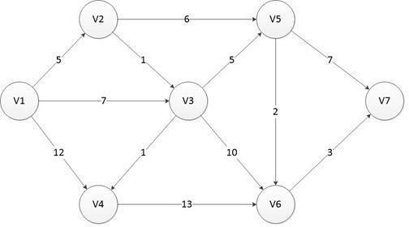

**Figure 2. Example of Dijkstra's Paths and nodes**

[3]

The results of implementation system will be tested using User Acceptance Test (UAT) method. In Fundamental Programming, Azminuddin et all [18] UAT is a way of testing the system by the user, then the user answers from options/choices or questions related to making the system in the quality of software work in the form of a questionnaire. System performance can be evaluated through the results of this questionnaire. The questions asked to the user using an answer scale between 1 to 5 with the following descriptions:

1. Scale 1 indicates Strongly Disagree
2. Scale 2 indicates Disagree
3. Scale 3 indicates Enough
4. Scale 4 indicates Agree
5. Scale 5 indicates Strongly Agree

The questions compiled in this questionnaire use the Usability Testing component [14], with 5 aspects that is:

1. Learnability, describes a measurement of the ease given to users in a basic test of system use.
2. Efficiency, users expend resources to achieve the accuracy and

completeness of objectives

1. Memorability is the level of ease that the user feels to return to using the system after some time.
2. Errors, a possibility of errors made by the user and the ease of overcoming these errors.
3. Satisfaction, a level of user satisfaction with the system that has been created.

This questionnaire was distributed to 24 users, which 4 are owners of motorcycle and car repair shops, 5 mechanics and 15 customers. This questionnaire will provide an overview of the assessment of the user interface and its usefulness. The questionnaire question show on Table 1. below:

**Table 1. Questionnaire Questions**

|  |  |
| --- | --- |
| **NO** | **Questions** |
| Learnability Aspect | |
| Q1 | This system is easy to understand? |
| Q2 | This system will make it easier to find and make orders online at a motorcycle or car repair shops? |
| Efficiency Aspect | |
| Q3 | The information provided through this system is responsive and helpful? |
| Q4 | This system has become a solution for vehicle users who need services? |
| Memorability Aspect | |
| Q5 | With this system, search and order services for motorcycle or car repair shops will be more effective. |
| Q6 | Can this system display the requested data? |
| Errors Aspect | |
| Q7 Is the system running properly without errors? | |
| Satisfaction Aspect | |
| Q8 | The user interface and menu features on this system are very good? |
| Q9 | This system will be recommended to others? |

UAT Formula :

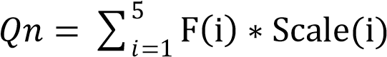 …………......(1)

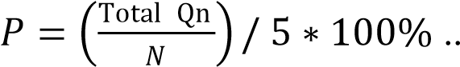…………...(2)

where :

Qn = Question (1,2,3….n) n = 1,2,3,…….9 F = Answer Frequency

Scale = Likert Scale

P = Percentage

N = Total Respondent

# DISCUSSION AND RESULT

The following is a use case diagram, system show on figure 3.

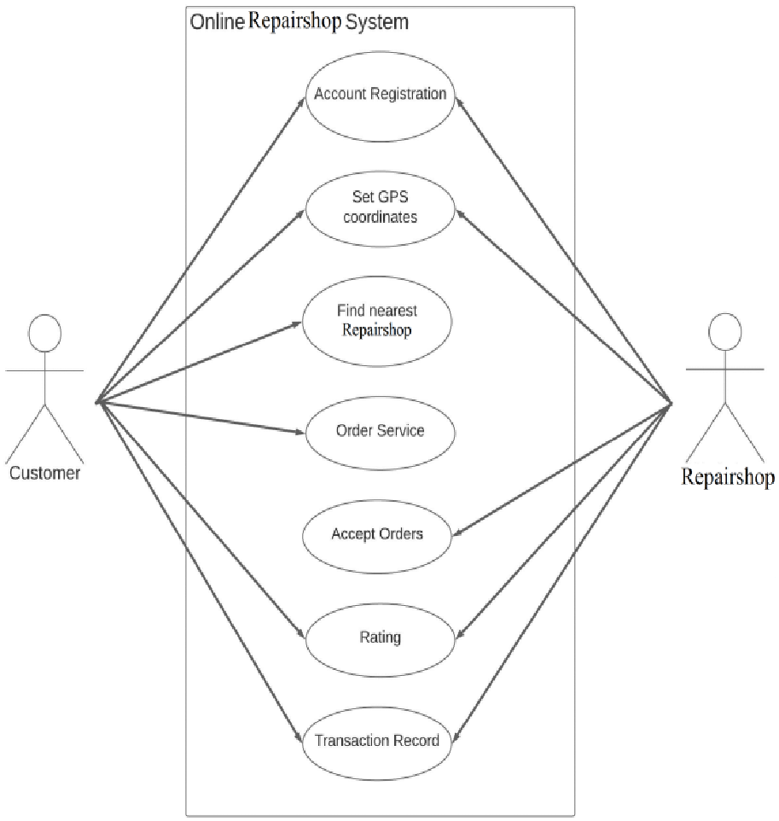

**Figure 3. Use Case Diagram System**

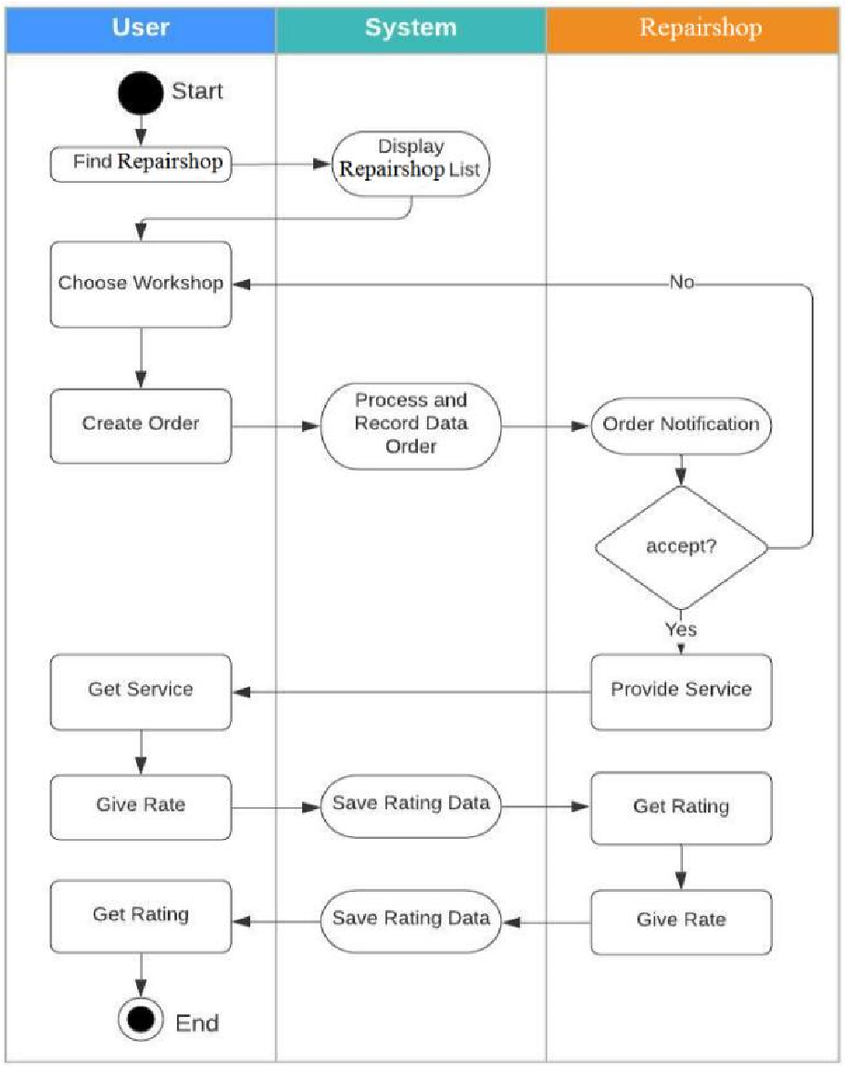

**Figure 4. Activity Diagram**

In figure 5. below is show a display of the main system page with a search menu for the nearest repair shop and a menu provided for customers.

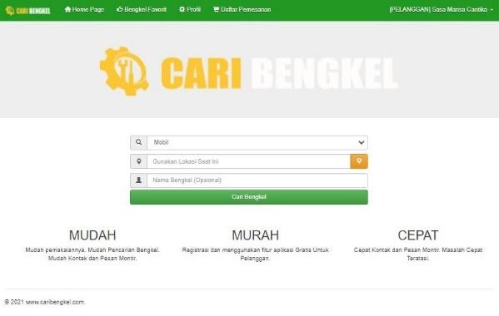

**Figure 5. Home Menu**

At figure 6. this page shows the repair shop locations on the map.

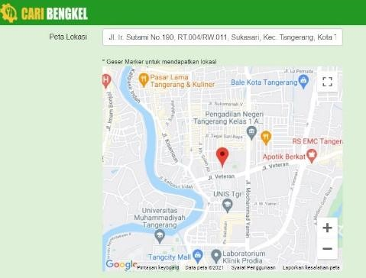

**Figure 6. Map Search Result**

Dijkstra is calculated by finding and determining the shortest route. See the following nodes on figure 7.

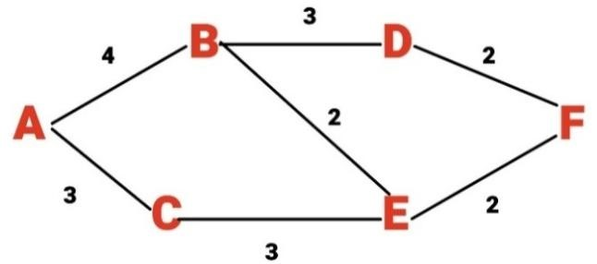

**Figure7. Dijkstra’s Path**

In this simulation, node A is the Start point and node F is the end point. Looking for the shortest route, start from node A with empty value = 0, and another node = ∞ "infinity", cause the number of distance still unknown. Seen on Table 2. below:

**Table 2. Dijkstra’s Count Simulation 1**

**A B C D E F**

0 ∞ ∞ ∞ ∞ ∞

Node A is connected to node B and node C. Then the value of the two nodes will be entered into the table. Between node B and node C, the lowest value is node C = 3, then node C will be a fixed value. Seen on Tabel 3. below:

**Table 3. Dijkstra’s Count Simulation 2**

**A B C D E F** 0 ∞ ∞ ∞ ∞ ∞

**From A** 0 4 3 ∞ ∞ ∞

Because the principle of this method is to find the shortest route, node C = 3 will be start point. For the unknown points, still fill with the 'infinity'. Node C is connected to node E with a distance value = 3. Then the value of node C to node E is 3+3 = 6. Node E will have a distance value = 6. Between node B and node E, the lowest distance value is node B, then node B will be a fixed value. Seen on Table 4. below:

**Table 4. Dijkstra’s Count Simulation 3**

**A B C D E F** 0 ∞ ∞ ∞ ∞ ∞

**From A** 0 4 3 ∞ ∞ ∞

**From C** 0 4 3 ∞ 6 ∞

Because the small value is node B, this time start point form node B. Node B is connected to node D and node E. Node B to node E is 4+2 = 6, which means the value remains the same. While node B to node D is 4+3=7. Between node D and E, the value of the distance of node E is the smallest, then it is used as a fixed value. Seen on Tabel 5. below:

**Table 5. Dijkstra’s Count Simulation 4**

**A B C D E F** 0 ∞ ∞ ∞ ∞ ∞

**From A** 0 4 3 ∞ ∞ ∞

**From C** 0 4 3 ∞ 6 ∞

**From B** 0 4 3 7 6 ∞

From node E to node F is 6+2=8, while from node D to node F has a distance of 7+2=9, then the value to be taken is the smallest value, which is 8. Between node D and node F, the value of the distance of node D is the smallect, then it is used as a fixed value. Seen on Table 6. below:

**Table 6. Dijkstra’s Count Simulation 5**

**A B C D E F** 0 ∞ ∞ ∞ ∞ ∞

**From A** 0 4 3 ∞ ∞ ∞

**From C** 0 4 3 ∞ 6 ∞

**From B** 0 4 3 7 6 ∞

**From E** 0 4 3 7 6 8

Because there are no more paths, node F has a final value = 8. The total values obtained, from node A to node F, the shortest path is A-C-E-F = 0-3-6-8, with a total distance = 17. While the path A-B-D-F= 0-4-7-8 has the result = 19 and the path A-B-E-F=0-4-6-8 has the result = 18. Seen on Table 7. below:

**Table 7. Dijkstra’s Count Simulation 5**

**A B C D E F** 0 ∞ ∞ ∞ ∞ ∞

**From A** 0 4 3 ∞ ∞ ∞

**From C** 0 4 3 ∞ 6 ∞

**From B** 0 4 3 7 6 ∞

**From E** 0 4 3 7 6 8

**From D** 0 4 3 7 6 8

The results above, the smallest route from node to node F is A-C-E-F path.

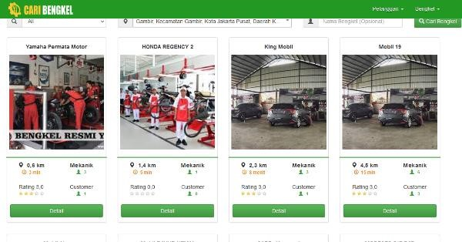

**Figure 8. Dijkstra Method Search Result**

After the system is successful in displaying search results, the order for a repair shop or mechanical service to come to the location will enter the transaction page and the order status will appear until it is finished and given a rating by the customer. It show on Figure 9. below.

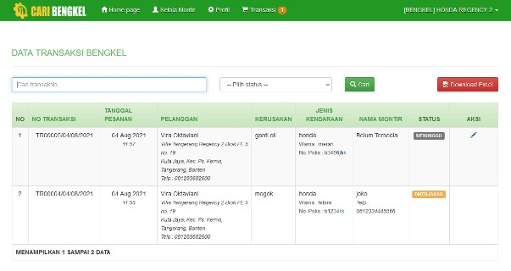

**Figure 9. Order Page**

On this page we can see information such as waiting status which means the repair shop or mechanic is full of customers. If there is a mechanic, the system will change the status to being in service. After all service processes are completed, we will be directed to a page to confirm and enter a review in the form of a rating.

Q4

0

0

9

44

50

103

85.8

%

Q5

0

0

3

44

60

107

89.2

%

Q6

0

0

18

32

50

100

%

83.3

10

24

0

6

0

9

From the

Table 9.

above, the

average

percentage from questionnaire

for each

aspect

is

:

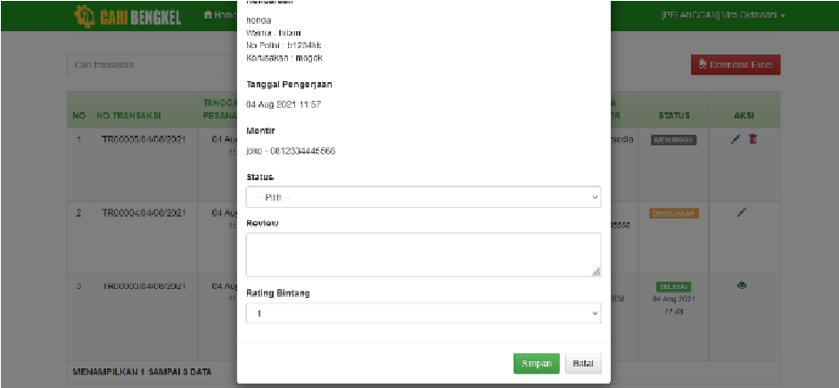

**Figure 10. Change Order Status and Rating**

**Page**

After the system was created, a feasibility test of the system was carried out by distributing questionnaires filled out by 24 respondents. The results of the questionnaire show on Table 8. below:

**Table 8. Respondents Answer Frequency**

|  |  |  |  |  |  |
| --- | --- | --- | --- | --- | --- |
| **NO** |  | **Answer Frequency Scale** | | |  |
| **1** | **2** | **3** | **4** | **5** |
| Q1 | 0 | 0 | 3 | 9 | 12 |
| Q2 | 0 | 0 | 2 | 7 | 15 |
| Q3 | 0 | 0 | 2 | 11 | 11 |
| Q4 | 0 | 0 | 3 | 11 | 10 |
| Q5 | 0 | 0 | 1 | 11 | 12 |
| Q6 | 0 | 0 | 6 | 8 | 10 |
| Q7 | 2 | 5 | 8 | 2 | 7 |
| Q8 | 0 | 0 | 2 | 9 | 13 |
| Q9 | 0 | 0 | 3 | 10 | 11 |

For the weight using formula (1) and the result for Total Q1 = (3*3) + (4*9) + (5*12) = 105 and to calculate percentage using formula (2). The result for Percentage Q1 = =

87.5%. The summary result for each question show on Table 9. below:

**Table 9. Respondents Answer Frequency**

Q1 105 87.5%

**NO**

**Answer Frequency**

**Scale**

**Total**

**Percentage**

**1**

**2**

**3**

**4**

**5**

0

0

9

36

60

Q2 0 0 6 28 75 109 90.8%

Q3 0 0 6 44 55 105 87.5%

Q7 2 8 35 79 65.8% Q8 0 36 65 107 89.2%

Q9 0 40 55 104 86.7%

Learnability Q1 and Q2 = 89.15%

Efficiency Q3 and Q4 = 86.65%

Memorability Q5 and Q6 = 86.25%

Errors Q7 = 65.80% Satisfaction Q8 and Q9 = 87.95%

Where total percentage is :

## (87,5 + 90,8 + 87,5 + 85,8 + 89,2 + 83,3 + 65,8 + 89,2 + 86,7)

9

= 85,1%

It can be concluded that 85.1% of respondents are satisfied with the system.

# CONCLUSION

Based on the system design that has been made, for Learnability aspect is 89.15%, Efficiency aspect is 86.65%, Memorability aspect is 86.25%, Errors aspect is 65.80%, and Satisfaction aspect is 87.95%. The total of average is 85.1% which means user satisfied with the system. The existence of this system can facilitate the community in terms of finding the nearest motorcycle or repair shop with appropriate facilities and also with this system, it is easier to communicate between the customer and the repair

**REFERENCES**

1. Badan Pusat Statistik, “Statistik Telekomunikasi Indonesia 2018,” *BPS - Statistics*

*Indonesia*, 2018. [Online]. Available:

https://www.bps.go.id/publication/2019/12/02/6799f23db22e9bdcf52c8e03/statistiktelekomunikasi-indonesia-2018.html. [Accessed: 20-Sep-2020].

1. Official U.S. Government, “Information About the Global Positioning System (GPS) and Related Topics,” *GPS.gov website*, 2020. [Online]. Available: https://www.gps.gov/systems/gps/. [Accessed: 20-Sep-2020].
2. A. S. Girsang, “Metode Algoritma Dijkstra,” *Universitas Bina Nusantara*, 2017. [Online]. Available: https://mti.binus.ac.id/2017/11/28/algoritma-dijkstra/. [Accessed: 20-Sep-2020].
3. Badan Pusat Statistik, “Perkembangan Jumlah Kendaraan Bermotor Menurut Jenis,”

*BPS - Statistics Indonesia*, 2019. [Online]. Available:

https://www.bps.go.id/indicator/17/57/1/perkembangan-jumlah-kendaraan-bermotormenurut-jenis.html. [Accessed: 20-Sep-2020].

1. D. Putra, B. Daniawan, S. Suwitno, and A. Wijaya, “The Analysis and Design Marketplace Information Systems Web-Based of Electronic Repair Service Providers with Haversine Method,” *bit-Tech*, vol. 2, no. 1, pp. 53–62, Nov. 2019.
2. S. Susandri, H. Spitri, L. Lusiana, and K. Harianto, “Apikasi Jasa Jahit Pakaian

Berbasis mobile dengan Teknologi Location Based Services dan Metode SMART,” *INOVTEK Polbeng - Seri Inform.*, vol. 5, no. 1, p. 128, 2020.

1. S. I. Purnawan, F. Marisa, and I. D. Wijaya, “Aplikasi Pencarian Pariwisata Dan

Tempat Oleh-Oleh Terdekat Menggunakan Metode Haversine Berbasis Android,” *J I M P - J. Inform. Merdeka Pasuruan*, vol. 3, no. 2, pp. 9–16, 2018.

1. A. N. Anastasia and I. Handriani, “Aplikasi Sistem Order Jasa Graphic Designer Berbasis Web Pada PT. Decorner,” *Ilm. FIFO*, vol. 10, no. 1, p. 87, 2018.
2. Y. Kurnia and Refin, “Ayam Gepuk Pak Gembus Web-Based Ordering Application Design With Codeigniter Framework,” *bit-Tech*, vol. 2, no. 2, 2020.
3. V. Meitasari, A. Nurdin, and Ariyanti, “Impementasi Metode Dijstra Dalam Mobile Aplikasi Pencarian SPBU Terdekat Di Kota Palembang,” in *Prosiding SNATIF ke-4 Tahun 2017*, 2017, vol. 5, pp. 96–101.
4. K. Thippeswamy, J. Hanumanthappa, and D. Manjaiah, “A Study on Contrast and Comparison between Bellman-Ford algorithm and Dijkstra’s algorithm,” in *National Conference on Wireless Networks-09 (NCOWN-2010)*, 2010, no. January.
5. R. Pramudita, H. Heryanto, R. Trias Handayanto, D. Setiyadi, R. W. Arifin, and N.

Safitri, “Shortest Path Calculation Algorithms for Geographic Information Systems,” *Proc. 2019 4th Int. Conf. Informatics Comput. ICIC 2019*, 2019.

1. V. Patel, “A Survey Paper of Bellman-Ford Algorithm and Dijkstra Algorithm for Finding Shortest Path in GIS Application,” *Int. J. P2P Netw. Trends Technol.*, vol. 5, no. 1, pp. 21–23, 2014.
2. R. Agustina and D. Suprianto, “Analisis Hasil Pemanfaatan Media Pembelajaran Interaktif Aljabar Logika Dengan User Acceptance Test (UAT),” *Smatika J.*, vol. 8, no. 2, pp. 67–73, 2018.
3. D. R. Lanning, G. K. Harrell, and Ji. Wang, “Dijkstra’s Algorithm and Google Maps,” in *ACM SE ’14: Proceedings of the 2014 ACM Southeast Regional Conference*, 2014, pp. 1–3.
4. E. W. Dijkstra, “A note on two problems in connexion with graphs,” *Numer. Math.*, vol. 1, no. 1, pp. 269–271, 1959.
5. P. L. Frana and T. J. Misa, “An Interview With Edsger W. Dijkstra,” *Communications of the ACM*, pp. 41–47, Aug-2010.
6. I. S. A. Azminuddin, Zohrahayaty, and Y. A. Mustofa, *Fundamental Pemrograman*. Yogyakarta: DEEPUBLISH, 2019.

**BIOGRAPHY**

**Vira Oktaviani Wijaya,** Currently working as Finance staff at PT. Indoseiki Metalutama and has completed his Strata I (S1) course in 2021 at the Information Systems Study Program at Buddhi Dharma University.

**Benny Daniawan,** Graduated in the Information Technology Study Program (S1) in 2011, continued his Masters in Information Systems in 2014, and graduated in 2016. He is currently a Lecturer Information Systems Study Program at Buddhi Dharma University.

**Primary Search:**

[View publication stats](https://www.researchgate.net/publication/355168146)

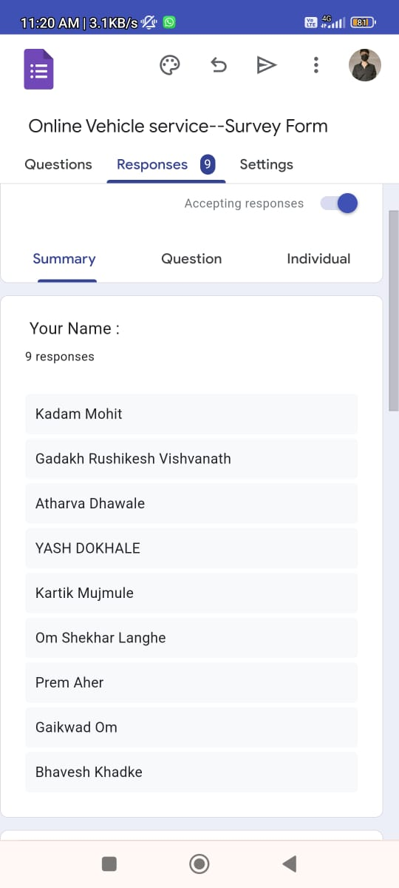

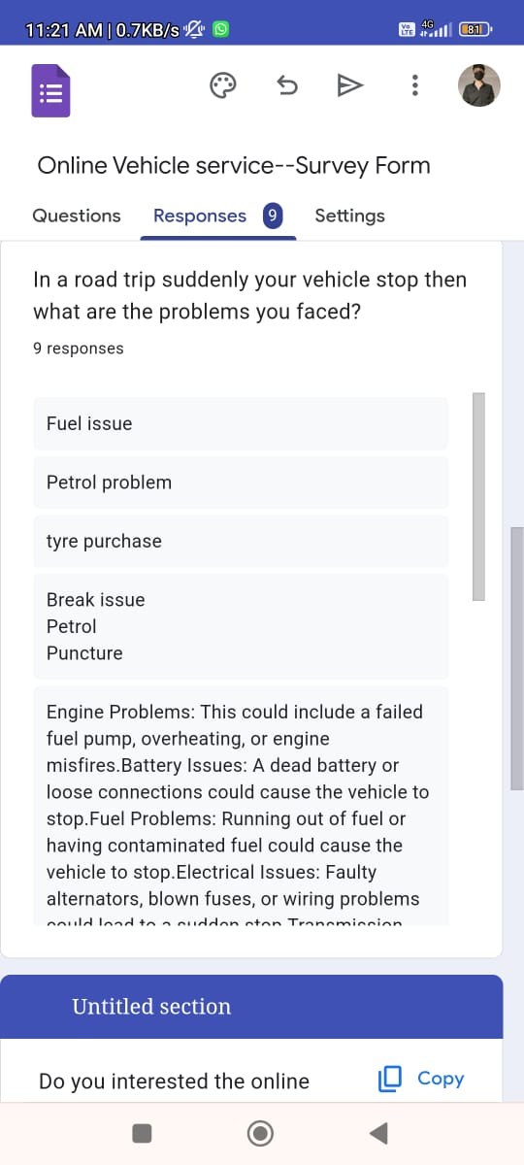

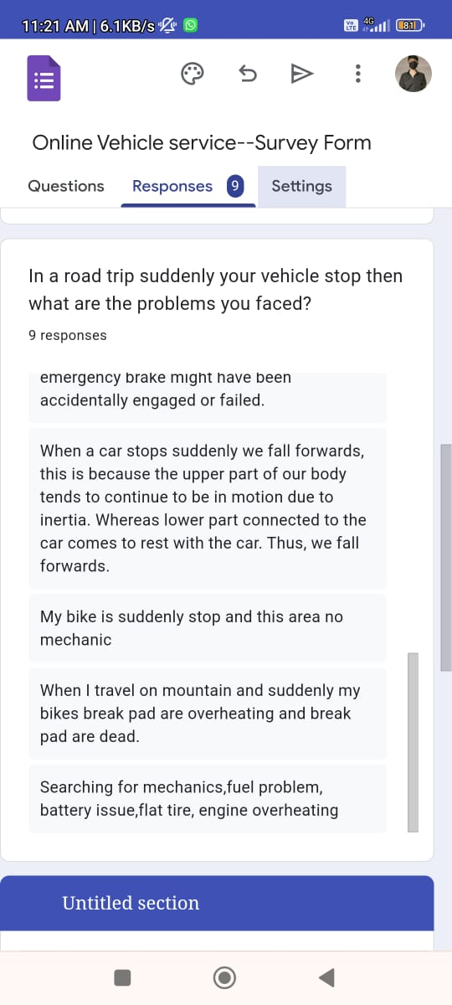

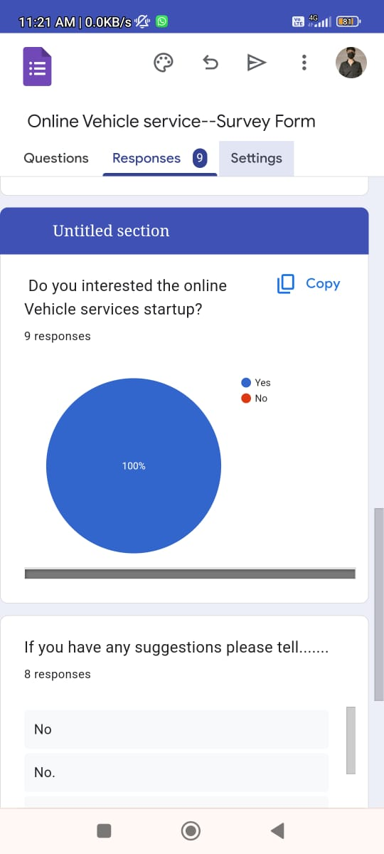

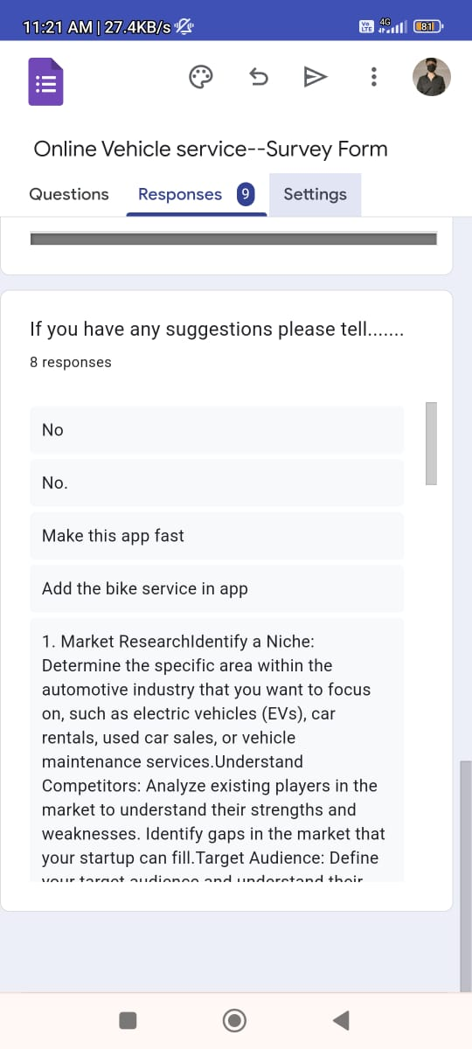

Activity:Process

**Background:**

Biography: A Mohit kadam Studying in Sanjivani University in AI-DS department. He is belongs from middle class family. He is leaving in Deolali pravara. He’s father is a farmer. He’s mother is a housewife. He want to become a AI engineer so he take admission in data science branch. And he also become a businessman. He what to become a success in he’s life. He’s father always support him so he proud on his father.

**Life Stage :** I am a student persuing my btech degree in AI-DS.  
**Daily routine :** wakes up at 7:00 AM , do classes from 10:30 am to 5:10 pm , at 6:30 to 7:30 I do class works ,at last socializes with friends before bed .

**Motivation:**  
**Primary goals :** I want to become a big businessman , and want to help a poor peopals.  
**Secondary goals:** Travel more , stay fit and grab knowledge of new things.  
**Motivation:** I want to success in my life.  
**Fear:** I don’t success in my life.  
**Doubts:** Weather I can speak English fluiently.  
**Challenges faced :**  
**Challenges :** Time management ,family supports.  
**Pain pont:** Distractions.

**Short story:**  
I am ,Mohit I belong from defence family my father Farmer , I want to becom a success , my motivation is chhatrapati shivaji maharaj . I like to travel and framing, I like to make a new friends  .